  
  Recognising and responding to acutely DETERIORATING PATIENTS
  This workshop is designed to develop confidence and skill in the recognition and management of adult patients showing signs of clinical deterioration.
  Through small group teaching sessions and clinical simulation scenarios, participants will increase their knowledge and comfort around assessing acutely deteriorating patients.
  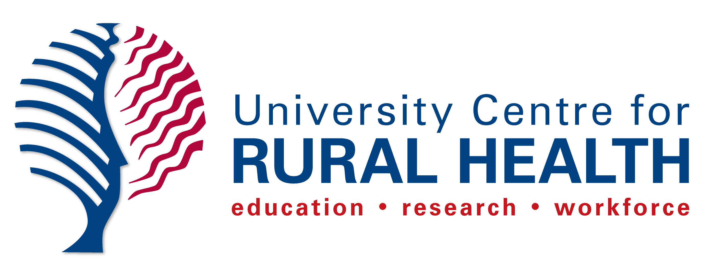
  WHEN
  THURSDAY
  25th OCTOBER
  2
  TIME
  9am – 1pm
  COST
  $85
  WHERE
  UCRH – 61 Uralba St, Lismore
  If you require any further information please contact the Simulation Team on 66207570, or email simulation@ucrh.edu.au
  If you wish to attend, please complete the online registration form or via QR code below

